CLASS: XII CYCLE TEST- BIOLOGY MARKS : 20
DATE: 29.8.19 Time: 40min

I. Answer the following questions:
1. Mention the type of allele that expresses itself only in homozygous state in an organism. (1)
2. State the ratio of ABO blood group multiple allelism when both the parents are heterozygous in condition. (1)
3. Draw the Punnett square for co dominance for coat colour in cattle. (2)
4. Give two example of each of the following:
a. Interallelic interaction b. Intraallelic interaction (2)
5. Mention the possible phenotype and genotype of the ABO blood. (3)

CLASS: XII CYCLE TEST- BIOLOGY MARKS : 20
DATE: 29.8.19 Time: 40min

I. Answer the following questions:
1. Mention the type of allele that expresses itself only in homozygous state in an organism. (1)
2. State the ratio of ABO blood group multiple allelism when both the parents are heterozygous in condition. (1)
3. Draw the Punnett square for co dominance for coat colour in cattle. (2)
4. Give two example of each of the following:
a. Interallelic interaction b. Intraallelic interaction (2)
5. Mention the possible phenotype and genotype of the ABO blood. (3)

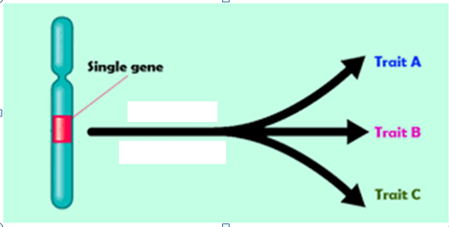
6. Identify the gene and state the significance of the gene. Write the name of the disorder. (3)

7. Is sickle cell anemia an example of point mutation? Explain it genetically. (3)
8. When the purple colour flower was crossed with white colour flower. The ratio we obtained was 9:7.
a. Identify the type of gene interaction
b. Draw the Punnett square
c. Mention how it is deviated from Mendel’s law and name the law also.
d. In which plant the experiment was conducted and Write the scientific name of the plant. (5)

6. Identify the gene and state the significance of the gene. Write the name of the disorder. (3)

7. Is sickle cell anemia an example of point mutation? Explain it genetically. (3)
8. When the purple colour flower was crossed with white colour flower. The ratio we obtained was 9:7.
a. Identify the type of gene interaction
b. Draw the Punnett square
c. Mention how it is deviated from Mendel’s law and name the law also.
d. In which plant the experiment was conducted and Write the scientific name of the plant. (5)

